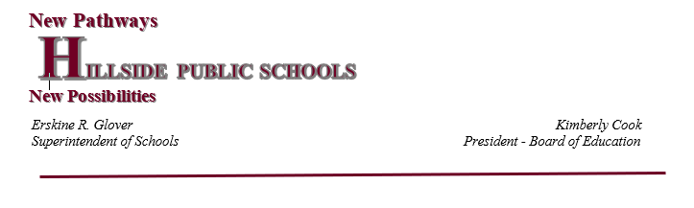

**Hillside Public Schools**

**2022-2023 Marking Period**

Total Days= 183

**Semester 1** – September 7 – February 1  90 days

**Semester 2** – February 2 – June 23           92 days

**MP Dates   Days Portal Open for Grade Reporting Portal Opens for Parents**

MP 1   September 7 – November 16                   46 days     November 9 -November 15     November 16, 2022

MP 2   November 17 – February 1                 46 days     January 25– January 31       February 1, 2023

MP 3   February 2 – April 18                 46 days           April 4 – April 17           April 18, 2023

MP 4   April 19 – June 23                         45 days         June 16 – June 22                 June 23, 2023

**Middle of Marking Periods Email Parent Grade Report**

Mid MP 1    October 11            23 days   October 11 – October 13

Mid MP 2    December 22        23 days   December 20 – December  22

Mid MP 3    March 8                 23 days March 8 – March 10

Mid MP 4    May 16                   23 days   May 15- May 17

**Final Exam Schedule**

Semester 1 Courses               January 24 – 28

Full Year and Semester 2 courses June 13 – 16

Make-Up Exams June 16 Session 2